Eligibility checklist
Statewide High Cost Medicines Formulary

Delamanid
50 mg tablet
Delamanid is listed on the High Cost Medicines formulary for the treatment of pulmonary drug resistant tuberculosis (DR-TB) at a dose of:
- 100 mg twice daily in adults
- 100 mg twice daily in adolescents and children (6-17 years) with a body weight of 50 kg and above
- 50 mg twice daily in adolescents and children (6-17 years) with a body weight of 30 kg or above and less than 50 kg
The duration of treatment is a maximum of 24 weeks. Continuation of treatment after 24 weeks will require further multidisciplinary consultation with SA Tuberculosis service.
Delamanid should be prescribed in compliance with the WHO guidelines (2019) which recommended that in DR-TB patients on longer regimens, all three Group A agents and at least one Group B agent should be included to ensure that treatment starts with at least four TB agents likely to be effective, and that at least three agents are included for the rest of treatment after bedaquiline is stopped. If only one or two Group A agents are used, both Group B agents are to be included. If the regimen cannot be composed with agents from Groups A and B alone, Group C agents are added to complete it.
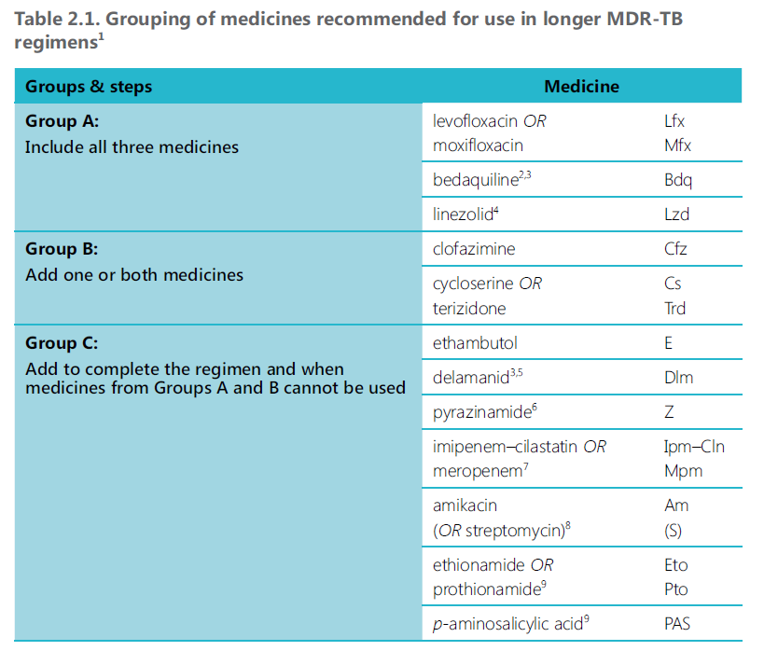

DR-TB is defined as caused by M. tuberculosis strains that are resistant to at least both isoniazid and rifampicin or intolerant/unable to use these agents.

The following information is required to be provided by the prescriber prior to dispensing of the high cost medicine:
Hospital:
Patient UR number:
Patient date of birth:
Patient weight:

Prescriber eligibility for delamanid:
- Thoracic physician OR Infectious Disease Physician after multidisciplinary team meeting with SA Tuberculosis Service

Patient eligibility for delamanid: (All first 4 criteria must be ticked and either the fifth or sixth one)
- Patient has been diagnosed with MDR-TB or DR-TB
- Patient has been receiving a treatment regimen compliant with the WHO guidelines.
- The patient’s treatment regimen cannot be only composed with medicines from Group A (bedaquiline, linezolid, levofloxacin/ moxifloxacin) and B (clofazimine, cycloserine) because of intolerance, adverse effects or interactions and where resistance to other Group C options such a pyrazinamide or ethambutol is proven or suspected
- Delamanid administration involves observed treatment
- Initial 24-week treatment of patient has been discussed with SA Tuberculosis service
- Continuation of treatment of patient after the initial 24-week treatment period has been discussed with SA Tuberculosis service

Outcome assessment
- Prescriber agrees to provide outcome measures (culture conversion, radiological and clinical improvement) following any 24-week treatment period to the SAMEP executive officer.

I certify that the above information is correct: ______________________________________
(Prescribers signature)
Date:
Name:
Position:
Department:
Contact/pager number: FORMTEXT

Information for pharmacy
This form should be retained in the pharmacy department and a copy forwarded to:
- The Executive Officer
South Australian Medicines Evaluation Panel
Medicines and Technology Policy and Programs
Level 1, 101 Grenfell St
Adelaide 5000
- (08) 7117 9805
- SAMEP@sa.gov.au

For more information:
http://www.sahealth.sa.gov.au/samep
Department for Health and Ageing, Government of South Australia. All rights reserved.

